Qualifying Exam

Chathrua Gunasekara

December 22, 2014

1.

1. Using the poisson distribution, p(X=0) given lambda = 3.2. probability that a particular month will have no accidents = 4%

dpois(0,3.2)

0.0407622

b. mean and the variance of the Poisson distribution are both equal to lambda.

Expected Value = lambda x 1 = 3.2

variance = lambda= 3.2

2.

a) $p(y≤2)$ = $p\left(y=0\right)+p\left(y=1\right)+p\left(y=2\right)=0.005+0.010+0.035=0.05$

b) $p\left(y=1,y=2,y=3,y=4\right)=1-p\left(y=0\right)=1-0.005=0.995$

c) $E\left(y\right)=\sum{y.p\left(y\right)}=0∙\left(0.005\right)+1∙0.010+2∙0.035+3∙0.050+4∙0.900=3.83$

$$d) E\left(y^{2}\right)=\sum{y^{2}∙p\left(y\right)}$$

= $0^{2}∙\left(0.005\right)+1^{2}∙0.010+2^{2}∙0.035+3^{2}∙0.050+4^{2}∙0.900=15$

So, the variance, $σ^{2}$ = $E\left(y^{2}\right)-{E(y)}^{2}$

= 15-(3.83)^2 = 0.3311

And standard deviation,

$σ=\sqrt{0.3311}=0.575413$

3.

mu = 70  
sigma = 3  
z socre for 64  
(64-70)/3

z = -2

z socre for 76

(76-70)/3

z = 2

#between -2 and +2  
pnorm(2) - pnorm(-2)

0.9544997

What % of males will be between 64 and 76 inches tall = 95.44 %

4.

a)Sample mean  
values <-c(13.3,14.5,15.3,15.3,14.3,14.8,15.2,14.9,14.6,14.1)  
mean(values)

14.63

b)sample variance  
var(values)

0.389

sample standard deviation  
sqrt(var(values))

0.6236986

c)

H0 : mu0 = 14.9

H1 : mu0 *≠ 14.9*

xbar <- 14.63 # sample mean   
mu0 <- 14.90 # hypothesized value   
s <- sqrt(0.389) # sample standard deviation   
n <- 10 # sample size   
  
test_statistic <- (xbar-mu0)/(s/sqrt(n))  
test_statistic *=* -1.368954

alpha = .01  
df <- n-1   
t.half.alpha <- qt(1-alpha/2,df=n-1)  
c(-t.half.alpha,t.half.alpha)

Confidence Interval :

(-3.249836 , 3.249836 ), If test statistics is between this interval we can not reject the null hypothesis.

Or using P values :

pval <- 2*pt(test_statistic,df=n-1)

pval = 0.2042047 > alpha therefor can not reject the null hypothesis.

d.

e <-qt(0.9,df=n-1)*s # Margin of Error  
e = 0.8625932

c(xbar-e,xbar+e)

Confidence Interval is (13.76741 15.49259)

#true mean is between this confidence interval so it has not been changed.

5)

1. c

1. b
2. c
3. c
4. a

6)

1) By observing the data set the categorical predictor “education” and the continuous predictor “education_num” represents the same information. So education_num was removed initially.

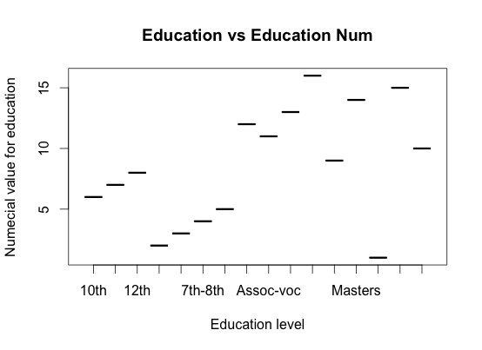

2. age and hr_per_week Continuous predictors were choose to scale. This applies a normal transformation. Each value minus its mean over the sample standard deviation. Following is the boxplots for these continuous predictors.

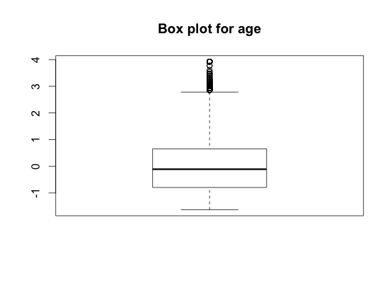

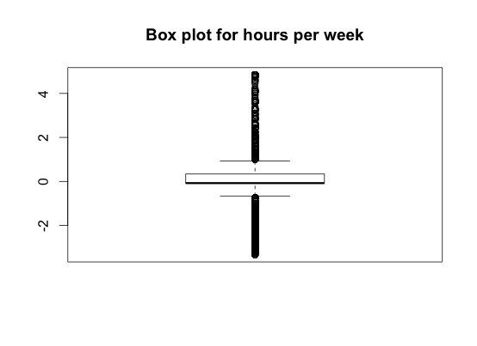

3. The capital gain and capital loss predictors are extremely skewed. No transformation could correct this. So the predictors were coverted to categorical varables with (None,Low,High) factors.

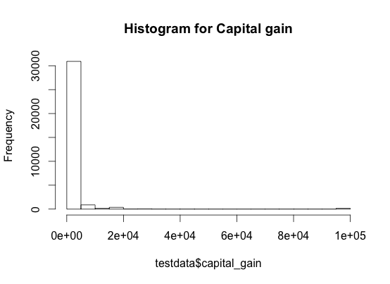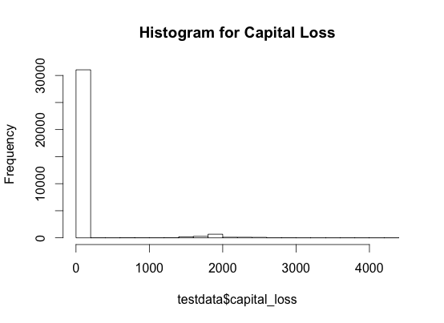

Because of the high skewers numerical transformation would not have been appropriate so Converted to Categorical variables. For both variables, none means they don’t play the market. Low means they have some investments. High means they have significant investments.

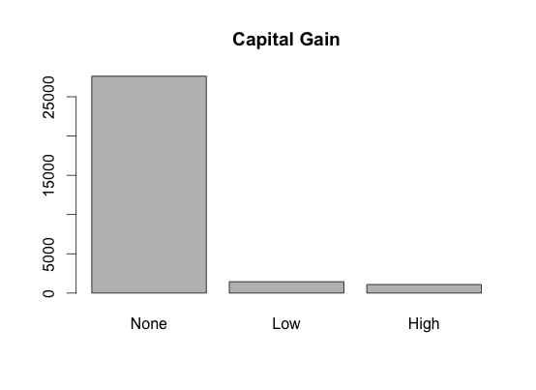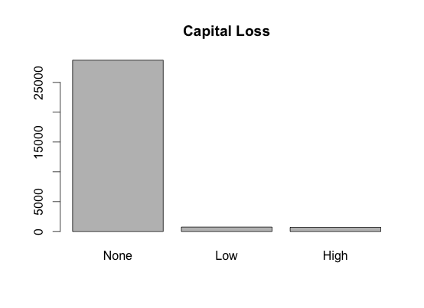

4. nearzerovar() function return following predictors are degenerate.

[1] "capital_gain"

[1] "capital_loss"

[1] "country"

Some predictors were recotagorized to include in to a broader category to reduce the number of factores in a predictor. (occupation,marital status, ect)

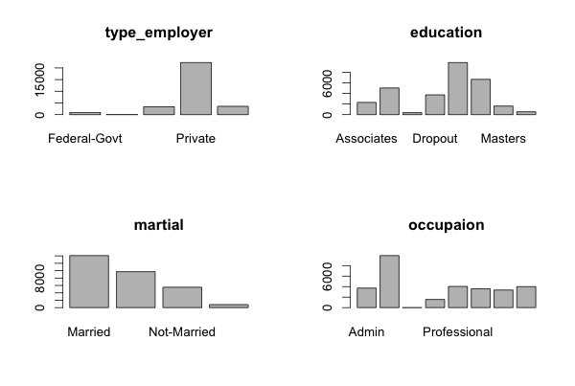

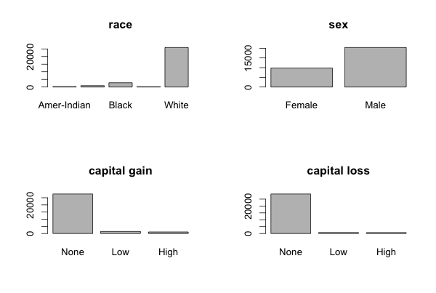

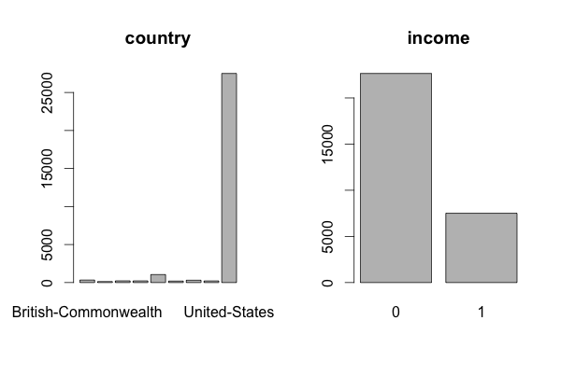

5. Missing value visualization

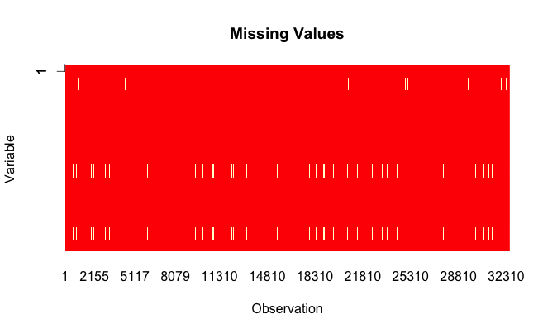

|  |  |
| --- | --- |
| Predictor | Overall Number of missing values |
| Type_employer | 1836 |
| Occupation | 1843 |
| country | 583 |

Yes. In low income (<=50,000) data points the number of missing values are high. Because low income people may not be able to give information more confidently as high income people. So there can be many missing values in a low in come data point.

6. Na.omit() function is used to omit the data with missing values beause it does not affet much as there are still more than 30,000 datapoint with complete data. Only about 2000 datapoint had to be removed because the missing data.

7. ROC or Kappa statistic should be used. Accuracy may not be the best statistic because the income class imbalance.

8. Response class is imbalanced.

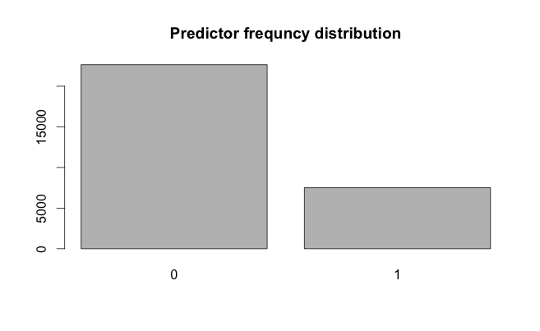

Stratified sampling should be used to split the dataset in to testing and training sets. The createDataPartition() function is used with p=0.75. which split the data set in to 75% training and 25% testing set.

9. Preprocessing steps:

i. Remove high correlated predictors

ii. Merge factors in categorical predictors so it will reduced the number of dummy variables created. For example the country predictors can be re categorized according the larger geographical region such as (Asia, Europe, South America, Africa, ect)

iii. Remove data points with missing values

iv. Remove no information predictors (fnlwgt) is just a number with no relevance to the income, such as an ID number.

v. Remove zero variance predictors

**30162 rows and 10 categorical Predictors are remaining after all the preprocessing. This dataset was split to following training and testing set.**

**22622 for training set**

**7540 for testing set**

To be used in some models, Dummy variables were created for all the categorical predictors using the same dataframe(30162 rows and 10 column) mentioned above. Then number of predictors increased to 28 predictors.

10. Linear Models

|  |  |  |  |  |
| --- | --- | --- | --- | --- |
| Model | Tuning Para. | AUC | Sensitivity | Specificity |
| Logistic reg | ------No--- | 0.87996 | 0.91717 | 0.55448 |
| LDA | -------No--- | 0.86991 | 0.91458 | 0.54237 |
| PLSDA | Ncome = 10 | 0.86886 | 0.9301 | 0.50191 |
| GLMNet | alpha = 0 and lambda = 0.1 | 0.86384 | 0.93842 | 0.45082 |
| Nearest S C | Threshold =0 | 0.84545 | 0.94131 | 0.39741 |

Important predictors from Linear model - PLSDA

age 0.08234

marital.Married 0.07472

relationship.Husband 0.06400

marital.Never-Married 0.04421

occupation.Blue-Collar 0.03361

occupation.White-Collar 0.03196

education.Bachelors 0.03138

education.HS-grad 0.03087

sex.Male 0.02983

sex.Female 0.02983

relationship.Not-in-family 0.02857

education.Dropout 0.02854

occupation.Professional 0.02814

relationship.Own-child 0.02513

marital.Not-Married 0.02473

occupation.Service 0.02161

education.Masters 0.01998

relationship.Unmarried 0.01714

type_employer.Private 0.01630

education.HS-Graduate 0.01203

11.

|  |  |  |  |  |
| --- | --- | --- | --- | --- |
| Model | Tuning Para | ROC | Sensitivity | Specificity |
| MDA | Subclasses = 1 | 0.87640 | 0.91652 | 0.55499 |
| NNet | Size = 1, decay =0.1 | 0.8872 | 0.90826 | 0.57705 |
| FDA | degree = 1 and nprune = 17. | 0.8763 | 0.9184 | 0.5478 |
| SVM | C=8 | 0.8793 | 0.9235 | 0.5818 |
| KNN | K=9 | 0.8809 | 0.8974 | 0.5715 |
| NaiveBayes | Laplace = 2 | 0.8723 | 0.8652 | 0.5253 |

12. Best models based on AUC

1. Neural Network , 2. KNN 3. SVM – from Non Linear models

1. Logistic Reg 2. LDA 3 . PLSDA – from Linea modelss

13.

From Linear best models are Logisted ,LDA, PLSDA

From Non linear best models are NeuralNet,

|  |  |  |  |  |
| --- | --- | --- | --- | --- |
| model | Accuracy | Sensitivity | Specificit | Kappa |
| Logistic | 0.8309 | 0.9202 | 0.5615 | 0.5158 |
| LDA | 0.8256 | 0.9163 | 0.5519 | 0.501 |
| PLSDA | 0.8236 | 0.9302 | 0.5019 | 0.4781 |
| Nnet | 0.8524 | 0.9129 | 0.5992 | 0.6212 |
| KNN | 0.8413 | 0.9135 | 0.5832 | 0.5419 |
| SVM | 0.8245 | 0.9161 | 0.5124 | 0.524 |

Based on the Kappa statistic Neural Network model is the best to classify the income.

14. Important predictors

maritalNever-Married 100.000

maritalNot-Married 83.698

educationBachelors 61.242

educationMasters 61.242

educationProf-School 54.926

age 48.643

educationDoctorate 42.061

occupationBlue-Collar 39.170

occupationWhite-Collar 36.761

maritalWidowed 30.950

hr_per_week 22.221

educationDropout 14.719

sexMale 11.332

relationshipWife 8.994

raceAsian 0.000

occupationMilitary 0.000

raceWhite 0.000

occupationSales 0.000

occupationOther-Occupations 0.000

relationshipNot-in-family 0.000

**Generalized Linear Model**

22622 samples

9 predictor

2 classes: '0', '1'

Resampling: Repeated Train/Test Splits Estimated (25 reps, 0.75%)

Summary of sample sizes: 16968, 16968, 16968, 16968, 16968, 16968, ...

Resampling results

ROC Sens Spec ROC SD Sens SD Spec SD

0.8799647 0.9171745 0.5544847 0.003771528 0.003718161 0.01107291

**Linear Discriminant Analysis**

22622 samples

28 predictor

2 classes: '0', '1'

Resampling: Repeated Train/Test Splits Estimated (25 reps, 0.75%)

Summary of sample sizes: 16968, 16968, 16968, 16968, 16968, 16968, ...

Resampling results

ROC Sens Spec ROC SD Sens SD Spec SD

0.8699113 0.9145844 0.5423738 0.004330018 0.0034694 0.01161766

**Partial Least Squares**

22622 samples

28 predictor

2 classes: '0', '1'

Resampling: Repeated Train/Test Splits Estimated (25 reps, 0.75%)

Summary of sample sizes: 16968, 16968, 16968, 16968, 16968, 16968, ...

Resampling results across tuning parameters:

ncomp ROC Sens Spec ROC SD Sens SD Spec SD

1 0.8210978 0.9254815 0.3017200 0.005172884 0.004257385 0.011524530

2 0.8484582 0.9169108 0.5011230 0.004623632 0.003693251 0.009662471

3 0.8556016 0.9229951 0.5017484 0.005319495 0.002918410 0.011519707

4 0.8613771 0.9274217 0.4864534 0.005105521 0.002653747 0.012626050

5 0.8632581 0.9286461 0.4915139 0.005045462 0.003048491 0.012534031

6 0.8648489 0.9273558 0.5007249 0.005025836 0.003253502 0.011862911

7 0.8666984 0.9302190 0.4949538 0.004959947 0.003485078 0.012873540

8 0.8679223 0.9303132 0.4993035 0.005013923 0.002984934 0.012224660

9 0.8681823 0.9301342 0.4976262 0.005143483 0.003351018 0.012741545

10 0.8688623 0.9301436 0.5019190 0.005076225 0.003489609 0.013201262

ROC was used to select the optimal model using the largest value.

The final value used for the model was ncomp = 9.

**glmnet**

22622 samples

28 predictor

2 classes: '0', '1'

Resampling: Repeated Train/Test Splits Estimated (25 reps, 0.75%)

Summary of sample sizes: 16968, 16968, 16968, 16968, 16968, 16968, ...

Resampling results across tuning parameters:

alpha lambda ROC Sens Spec ROC SD Sens SD Spec SD

0.0 0.1 0.8638485 0.9384224 0.450859986 0.005655341 0.0043027220 0.012347593

0.0 0.2 0.8610042 0.9563551 0.375977257 0.005745578 0.0034350049 0.010700393

0.0 20.0 0.8480020 1.0000000 0.000000000 0.005945144 0.0000000000 0.000000000

0.2 0.1 0.8604895 0.9608288 0.340810235 0.005702182 0.0035831254 0.012370141

0.2 0.2 0.8531465 0.9989451 0.009182658 0.005966442 0.0007356016 0.005218438

0.2 20.0 0.5000000 1.0000000 0.000000000 0.000000000 0.0000000000 0.000000000

0.6 0.1 0.8454274 1.0000000 0.000000000 0.006374152 0.0000000000 0.000000000

0.6 0.2 0.7587508 1.0000000 0.000000000 0.005908302 0.0000000000 0.000000000

0.6 20.0 0.5000000 1.0000000 0.000000000 0.000000000 0.0000000000 0.000000000

0.8 0.1 0.8067229 1.0000000 0.000000000 0.016570798 0.0000000000 0.000000000

0.8 0.2 0.7575690 1.0000000 0.000000000 0.005723933 0.0000000000 0.000000000

0.8 20.0 0.5000000 1.0000000 0.000000000 0.000000000 0.0000000000 0.000000000

ROC was used to select the optimal model using the largest value.

The final values used for the model were alpha = 0 and lambda = 0.1.

**Nearest Shrunken Centroids**

22622 samples

28 predictor

2 classes: '0', '1'

Pre-processing: centered, scaled

Resampling: Repeated Train/Test Splits Estimated (25 reps, 0.75%)

Summary of sample sizes: 16968, 16968, 16968, 16968, 16968, 16968, ...

Resampling results across tuning parameters:

threshold ROC Sens Spec ROC SD Sens SD Spec SD

0 0.8454513 0.9413139 0.397412935 0.004319150 0.0039207738 0.009172483

1 0.8453774 0.9468707 0.370206112 0.004381660 0.0037334138 0.008593492

2 0.8452393 0.9541323 0.338678038 0.004470150 0.0035947885 0.009051073

3 0.8450614 0.9622227 0.299587775 0.004512389 0.0030314698 0.009592952

4 0.8447973 0.9746645 0.230362473 0.004561640 0.0026193308 0.008477597

5 0.8444082 0.9863998 0.140639659 0.004629258 0.0025697198 0.008070591

6 0.8437068 0.9958276 0.045088842 0.004727403 0.0009908936 0.008072573

7 0.8424795 0.9995950 0.002501777 0.004913761 0.0003755082 0.001437952

8 0.8396445 1.0000000 0.000000000 0.005264669 0.0000000000 0.000000000

9 0.8346362 1.0000000 0.000000000 0.005436800 0.0000000000 0.000000000

10 0.8289169 1.0000000 0.000000000 0.005691125 0.0000000000 0.000000000

11 0.8190368 1.0000000 0.000000000 0.006370865 0.0000000000 0.000000000

12 0.8092706 1.0000000 0.000000000 0.006857796 0.0000000000 0.000000000

13 0.8062404 1.0000000 0.000000000 0.005685198 0.0000000000 0.000000000

14 0.8027894 1.0000000 0.000000000 0.006408375 0.0000000000 0.000000000

15 0.7925135 1.0000000 0.000000000 0.007596168 0.0000000000 0.000000000

16 0.7691202 1.0000000 0.000000000 0.008435752 0.0000000000 0.000000000

17 0.7664731 1.0000000 0.000000000 0.005018473 0.0000000000 0.000000000

18 0.7664731 1.0000000 0.000000000 0.005018473 0.0000000000 0.000000000

19 0.7664731 1.0000000 0.000000000 0.005018473 0.0000000000 0.000000000

20 0.7664731 1.0000000 0.000000000 0.005018473 0.0000000000 0.000000000

21 0.7664731 1.0000000 0.000000000 0.005018473 0.0000000000 0.000000000

22 0.7571205 1.0000000 0.000000000 0.005208846 0.0000000000 0.000000000

23 0.7571205 1.0000000 0.000000000 0.005208846 0.0000000000 0.000000000

24 0.7571205 1.0000000 0.000000000 0.005208846 0.0000000000 0.000000000

25 0.7571205 1.0000000 0.000000000 0.005208846 0.0000000000 0.000000000

ROC was used to select the optimal model using the largest value.

The final value used for the model was threshold = 0.

**Neural Network**

22622 samples

9 predictor

2 classes: '0', '1'

No pre-processing

Resampling: Repeated Train/Test Splits Estimated (25 reps, 0.75%)

Summary of sample sizes: 16968, 16968, 16968, 16968, 16968, 16968, ...

Resampling results across tuning parameters:

size decay ROC Sens Spec ROC SD Sens SD Spec SD

1 0.000 0.8705316 0.8970944 0.5891969 0.014219352 0.015329727 0.03285999

1 0.001 0.8787454 0.9099788 0.5737313 0.006186793 0.004157792 0.01368856

1 0.100 0.8802671 0.9082647 0.5770576 0.003869122 0.004125598 0.01144904

1 1.000 0.8802317 0.9053826 0.5840512 0.003832171 0.004103522 0.01116490

ROC was used to select the optimal model using the largest value.

The final values used for the model were size = 1 and decay = 0.1.

**Flexible Discriminant Analysis**

22622 samples

9 predictor

2 classes: '0', '1'

Resampling: Repeated Train/Test Splits Estimated (25 reps, 0.75%)

Summary of sample sizes: 16968, 16968, 16968, 16968, 16968, 16968, ...

Resampling results across tuning parameters:

nprune ROC Sens Spec ROC SD Sens SD Spec SD

2 0.3292055 1.0000000 0.0000000 0.004894496 0.000000000 0.0000000

9 0.8477668 0.9327431 0.4535608 0.005429629 0.009875514 0.0322599

17 0.8763237 0.9184083 0.5478038 0.004233990 0.005295729 0.0110436

Tuning parameter 'degree' was held constant at a value of 1

ROC was used to select the optimal model using the largest value.

The final values used for the model were degree = 1 and nprune = 17.

**k-Nearest Neighbors**

22622 samples

28 predictor

2 classes: '0', '1'

Resampling: Repeated Train/Test Splits Estimated (25 reps, 0.75%)

Summary of sample sizes: 16968, 16968, 16968, 16968, 16968, 16968, ...

Resampling results across tuning parameters:

k ROC Sens Spec ROC SD Sens SD Spec SD

3 0.8233105 0.8877796 0.5502203 0.005330046 0.005281699 0.01379943

5 0.8428730 0.8939393 0.5613362 0.004777924 0.005070641 0.01581545

9 0.8580986 0.8974523 0.5715991 0.004465693 0.005023055 0.01416908

ROC was used to select the optimal model using the largest value.

The final value used for the model was k = 9.

**Naive Bayes Classifier for Discrete Predictors**

Call:

naiveBayes.default(x = trainX, y = trainY)

A-priori probabilities:

trainY

0 1

0.751083 0.248917

Conditional probabilities:

age

trainY [,1] [,2]

0 -0.1348400 1.0285740

1 0.4130562 0.7764739

type_employer

trainY Federal-Govt Not-Working Other-Govt Private Self-Employed

0 0.0250720970 0.0005296922 0.1054676005 0.7698781708 0.0990524395

1 0.0458177944 0.0000000000 0.1287515539 0.6515716569 0.1738589948

education

trainY Associates Bachelors Doctorate Dropout HS-grad HS-Graduate Masters Prof-School

0 0.075922547 0.127596963 0.003884409 0.155258666 0.361838620 0.237949503 0.031722677 0.005826614

1 0.081690641 0.283786184 0.035872847 0.030190020 0.214526727 0.177943527 0.121115255 0.054874800

marital

trainY Married Never-Married Not-Married Widowed

0 0.33753163 0.40839268 0.22023424 0.03384145

1 0.85277926 0.06233351 0.07423193 0.01065530

occupation

trainY Admin Blue-Collar Military Other-Occupations Professional Sales Service White-Collar

0 0.1421929257 0.3660761580 0.0002354188 0.0460243658 0.0971102348 0.1157083162 0.1430168913 0.0896356895

1 0.0674835731 0.2214526727 0.0001775884 0.0644645711 0.2413425679 0.1250221985 0.0184691884 0.2615876399

relationship

trainY Husband Not-in-family Other-relative Own-child Unmarried Wife

0 0.298040139 0.302925078 0.037137308 0.196633512 0.133305868 0.031958095

1 0.754395312 0.108684070 0.005150062 0.008346652 0.029834843 0.093589061

race

trainY Amer-Indian Asian Black Other White

0 0.011005827 0.028073686 0.110999941 0.009475605 0.840444941

1 0.004439709 0.033386610 0.048481620 0.003019002 0.910673060

sex

trainY Female Male

0 0.3850862 0.6149138

1 0.1505949 0.8494051

hr_per_week

trainY [,1] [,2]

0 -0.1347207 1.0011172

1 0.4015488 0.8871906